实验报告
2019 年 5 月 16 日 成绩：
姓名 |  | 学号 |  | 班级
专业 | 计算机科学与技术 |  | 课程名称 | 计算机组成原理课程设计
任课老师 | 章复嘉 | 指导老师 | 章复嘉 | 机位号
实验序号 | 实验五 | 实验名称 | 寄存器设计实验
实验时间 | 2019.5.16 | 实验地点 | 1-225 | 实验设备号
一、实验目的和实验要求
掌握灵活运用Verilog HDL语言进行各种描述与建模的技巧和方法；
学习在ISE /Vavido中使用Memory IP核生成存储器的方法；
学习存储器的结构及读写原理，掌握存储器的设计方法。
学习MIPS指令系统，熟悉MIPS指令格式及其汇编指令助记符，掌握机器指令编码方法；
学习MIPS汇编程序设计，学会使用MIPS汇编器将汇编语言程序翻译成二进制文件；
了解使用MIPS教学系统模拟器运行程序的方法；
二、实验程序源代码
`timescale 1ns / 1ps

module RAM_B_top(clk,sw,led,swb,which,seg,enable);
input [1:32]sw;
input [6:1]swb;
input clk; // 数码管相关
output [2:0] which;
output [7:0] seg;
output reg enable = 1; // 默认开启数码管使能
output reg [1:32]led;
reg [6:1]addra;
reg [32:1]dina;
wire [32:1]douta;
RAM_B ram(
.clka(swb[1]),//时钟信号端口
.wea(swb[2]),//写控制信号端口
.addra(addra),//读写地址端口
.dina(dina),//写的数据端口
.douta(douta)//读的数据端口
);

Display Display_Instance(.clk(clk), .data(douta),
.which(which), .seg(seg));

always@(*)
begin
if(!swb[2])//读操作
begin
addra = sw[1:6];
led = douta;
end
else // 写操作
begin
addra = sw[1:6];
if(swb[3]) begin
dina = sw[1:32];
led = dina;
end
end

end
endmodule

//
//同时按下swb1,2,3,写入

IP核采用的.coe文件，使用Qtspim运行MIPS汇编器与模拟器实验中的代码生成，内容如下：
nor $1, $0,$0; #$1=FFFF_FFFF
sltu $2, $0, $1; #$2=0000_0001
add $3, $2, $2; #$3=0000_0002
add $4, $3, $2; #$4=0000_0003
add $5, $4, $3; #$5=0000_0005
add $6, $5, $3; #$6=0000_0007
sllv $7, $6, $2; #$7=0000_000E
add $9, $5, $6; #$9=0000_000C
sllv $8, $6, $9; #$8=0000_7000
xor $9, $1, $8; #$9=FFFF_8FFF
add $10, $9, $1; #$10=FFFF_8FFE
sub $11, $8, $7; #$11=0000_6FF2
sub $12, $7, $8; #$12=FFFF_900E
and $13, $9, $12; #$13=FFFF_800E
or $14, $9, $12; #$14=FFFF_9FFF
or $15, $6, $7; #$15=0000_000F
nor $16, $6, $7; #$16=FFFF_FFF0
add $17, $7, $3; #$17=0000_0010
sllv $18, $8, $17; #$18=7000_0000
sllv $19, $3, $17; #$19=0002_0000
sllv $20, $19, $7; #$20=8000_0000
add $21, $20, $1; #$21=7FFF_FFFF
or $22, $18, $21; #$22=7FFF_FFFF
add $23, $20, $22; #$23=FFFF_FFFF
sub $24, $20, $22; #$24=0000_0001
sub $25, $22, $20; #$25=FFFF_FFFF
xor $26, $18, $1; #$26=8FFF_FFFF
sltu $27, $22, $20; #$27=0000_0001
sltu $28, $26, $20; #$28=0000_0000
add $29, $22, $2; #$29=8000_0000
sub $30, $20, $2; #$30=7FFF_FFFF
add $31, $11, $26; #$30=9000_6FF1

.coe文件
memory_initialization_radix=16;

memory_initialization_vector=00000827 0001102b 00421820 00622020 00832820 00a33020 00463804 00a64820 01264004
00284826 01215020 01075822 00e86022 012c6824 012c7025 00c77825 00c78027 00e38820 02289004 02239804 00f3a004
0281a820 0255b025 0296b820 0296c022 02d4c822 0241d026 02d4d82b 0354e02b 02c2e820 0282f022 017af820;
三、仿真文件和波形图（有就填，没有就不填）
`timescale 1ns / 1ps
//测试模块
module Test_RAM_B();
reg [7:0]addra;//读出和写入的地址
reg [31:0]dina;//写入的数据
reg clka, wea;//时钟和，写控制信号(高电平有效)，在时钟上升沿时写入，读也是上升沿
wire [31:0]douta;//读出的数据，输出
initial clka=0;
always #25 clka=~clka; //每25ns，时钟翻转一次
initial//数据初始化
begin
addra=8'h00;wea=1'b0;
addra=8'h01;#50;
addra=8'h02;#50;
addra=8'h03;#50;
addra=8'h04;#50;
addra=8'h05;#50;
addra=8'h06;#50;
addra=8'h07;#50;
addra=8'h08;#50;
addra=8'h09;#50;
addra=8'h04;#50;
wea=1'b1;dina=32'h12345678;#50;
wea=1'b0;addra=8'h04;#50;
end

RAM_B test(
.clka(clka),//时钟信号端口
.wea(wea),//写控制信号端口
.addra(addra),//读写地址端口
.dina(dina),//写的数据端口
.douta(douta)//读的数据端口
);
endmodule
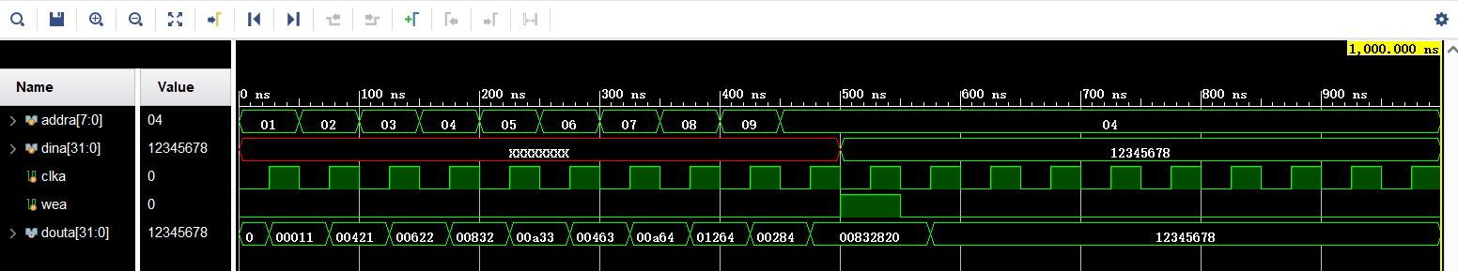
四、电路图（有就填，没有就不填）
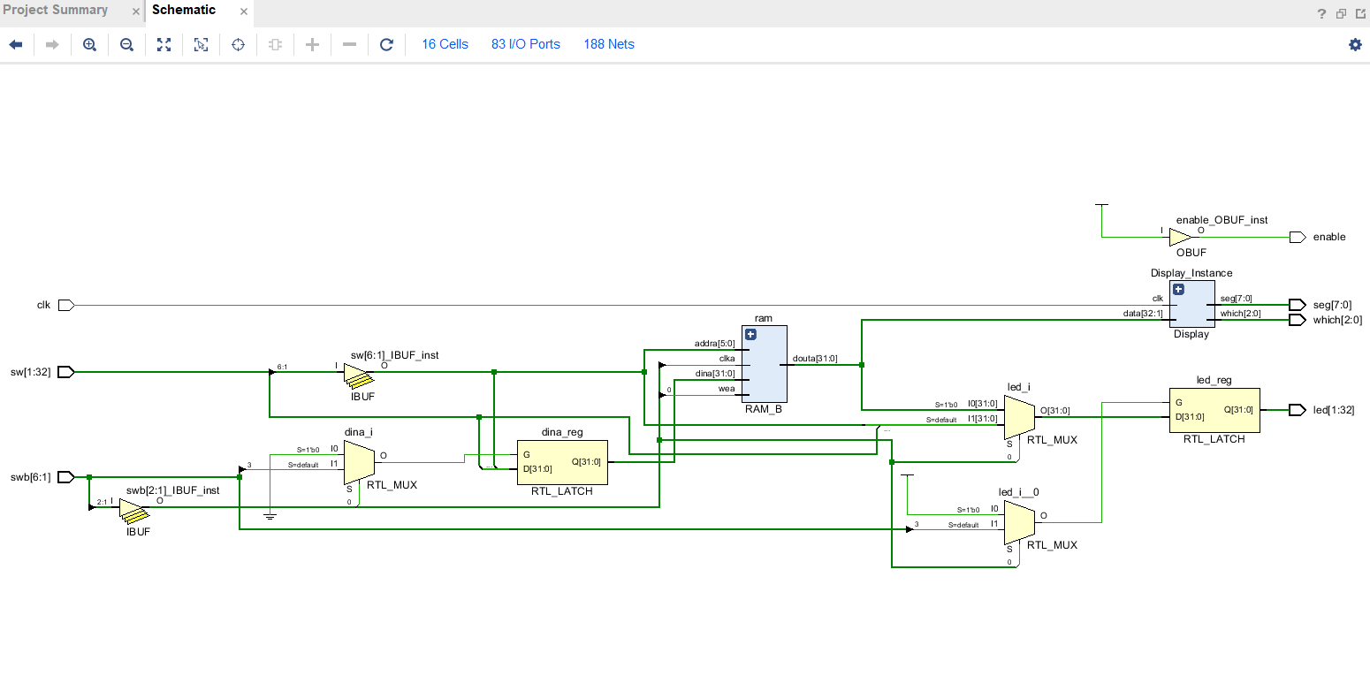
五、引脚配置（约束文件，有就填，没有就不填））
# 开启比特流压缩，优化 .bit 文件大小
set_property BITSTREAM.GENERAL.COMPRESS TRUE [current_design]

# Switch，开关
set_property PULLDOWN true [get_ports sw]
set_property IOSTANDARD LVCMOS18 [get_ports sw]
set_property PACKAGE_PIN T3 [get_ports {sw[1]}]
set_property PACKAGE_PIN U3 [get_ports {sw[2]}]
set_property PACKAGE_PIN T4 [get_ports {sw[3]}]
set_property PACKAGE_PIN V3 [get_ports {sw[4]}]
set_property PACKAGE_PIN V4 [get_ports {sw[5]}]
set_property PACKAGE_PIN W4 [get_ports {sw[6]}]
set_property PACKAGE_PIN Y4 [get_ports {sw[7]}]
set_property PACKAGE_PIN Y6 [get_ports {sw[8]}]
set_property PACKAGE_PIN W7 [get_ports {sw[9]}]
set_property PACKAGE_PIN Y8 [get_ports {sw[10]}]
set_property PACKAGE_PIN Y7 [get_ports {sw[11]}]
set_property PACKAGE_PIN T1 [get_ports {sw[12]}]
set_property PACKAGE_PIN U1 [get_ports {sw[13]}]
set_property PACKAGE_PIN U2 [get_ports {sw[14]}]
set_property PACKAGE_PIN W1 [get_ports {sw[15]}]
set_property PACKAGE_PIN W2 [get_ports {sw[16]}]
set_property PACKAGE_PIN Y1 [get_ports {sw[17]}]
set_property PACKAGE_PIN AA1 [get_ports {sw[18]}]
set_property PACKAGE_PIN V2 [get_ports {sw[19]}]
set_property PACKAGE_PIN Y2 [get_ports {sw[20]}]
set_property PACKAGE_PIN AB1 [get_ports {sw[21]}]
set_property PACKAGE_PIN AB2 [get_ports {sw[22]}]
set_property PACKAGE_PIN AB3 [get_ports {sw[23]}]
set_property PACKAGE_PIN AB5 [get_ports {sw[24]}]
set_property PACKAGE_PIN AA6 [get_ports {sw[25]}]
set_property PACKAGE_PIN R2 [get_ports {sw[26]}]
set_property PACKAGE_PIN R3 [get_ports {sw[27]}]
set_property PACKAGE_PIN T6 [get_ports {sw[28]}]
set_property PACKAGE_PIN R6 [get_ports {sw[29]}]
set_property PACKAGE_PIN U7 [get_ports {sw[30]}]
set_property PACKAGE_PIN AB7 [get_ports {sw[31]}]
set_property PACKAGE_PIN AB8 [get_ports {sw[32]}]

# Switch Button，按钮
set_property IOSTANDARD LVCMOS18 [get_ports swb]
set_property PACKAGE_PIN R4 [get_ports {swb[1]}]
set_property PACKAGE_PIN AA4 [get_ports {swb[2]}]
set_property PACKAGE_PIN AB6 [get_ports {swb[3]}]
set_property PACKAGE_PIN T5 [get_ports {swb[4]}]
set_property PACKAGE_PIN V8 [get_ports {swb[5]}]
set_property PACKAGE_PIN AA8 [get_ports {swb[6]}]

# LED
set_property IOSTANDARD LVCMOS18 [get_ports led]
set_property PACKAGE_PIN R1 [get_ports {led[1]}]
set_property PACKAGE_PIN P2 [get_ports {led[2]}]
set_property PACKAGE_PIN P1 [get_ports {led[3]}]
set_property PACKAGE_PIN N2 [get_ports {led[4]}]
set_property PACKAGE_PIN M1 [get_ports {led[5]}]
set_property PACKAGE_PIN M2 [get_ports {led[6]}]
set_property PACKAGE_PIN L1 [get_ports {led[7]}]
set_property PACKAGE_PIN J2 [get_ports {led[8]}]
set_property PACKAGE_PIN G1 [get_ports {led[9]}]
set_property PACKAGE_PIN E1 [get_ports {led[10]}]
set_property PACKAGE_PIN D2 [get_ports {led[11]}]
set_property PACKAGE_PIN A1 [get_ports {led[12]}]
set_property PACKAGE_PIN L3 [get_ports {led[13]}]
set_property PACKAGE_PIN G3 [get_ports {led[14]}]
set_property PACKAGE_PIN K4 [get_ports {led[15]}]
set_property PACKAGE_PIN G4 [get_ports {led[16]}]
set_property PACKAGE_PIN K1 [get_ports {led[17]}]
set_property PACKAGE_PIN J1 [get_ports {led[18]}]
set_property PACKAGE_PIN H2 [get_ports {led[19]}]
set_property PACKAGE_PIN G2 [get_ports {led[20]}]
set_property PACKAGE_PIN F1 [get_ports {led[21]}]
set_property PACKAGE_PIN E2 [get_ports {led[22]}]
set_property PACKAGE_PIN D1 [get_ports {led[23]}]
set_property PACKAGE_PIN B1 [get_ports {led[24]}]
set_property PACKAGE_PIN B2 [get_ports {led[25]}]
set_property PACKAGE_PIN N3 [get_ports {led[26]}]
set_property PACKAGE_PIN M3 [get_ports {led[27]}]
set_property PACKAGE_PIN K3 [get_ports {led[28]}]
set_property PACKAGE_PIN H3 [get_ports {led[29]}]
set_property PACKAGE_PIN N4 [get_ports {led[30]}]
set_property PACKAGE_PIN L4 [get_ports {led[31]}]
set_property PACKAGE_PIN J4 [get_ports {led[32]}]

# 数码管相关
set_property IOSTANDARD LVCMOS18 [get_ports seg]
set_property PACKAGE_PIN H19 [get_ports {seg[7]}]
set_property PACKAGE_PIN G20 [get_ports {seg[6]}]
set_property PACKAGE_PIN J22 [get_ports {seg[5]}]
set_property PACKAGE_PIN K22 [get_ports {seg[4]}]
set_property PACKAGE_PIN K21 [get_ports {seg[3]}]
set_property PACKAGE_PIN H20 [get_ports {seg[2]}]
set_property PACKAGE_PIN H22 [get_ports {seg[1]}]
set_property PACKAGE_PIN J21 [get_ports {seg[0]}]
set_property IOSTANDARD LVCMOS18 [get_ports which]
set_property PACKAGE_PIN N22 [get_ports {which[0]}]
set_property PACKAGE_PIN M21 [get_ports {which[1]}]
set_property PACKAGE_PIN M22 [get_ports {which[2]}]
set_property -dict {IOSTANDARD LVCMOS18 PACKAGE_PIN L21} [get_ports enable]
set_property -dict {IOSTANDARD LVCMOS18 PACKAGE_PIN H4} [get_ports clk]

# [Place 30-574] Poor placement for routing between an IO pin and BUFG.If this
# sub optimal condition is acceptable for this design, you may use the
# CLOCK_DEDICATED_ROUTE constraint in the .xdc file to demote this message to a
# WARNING. However, the use of this override is highly discouraged.
set_property CLOCK_DEDICATED_ROUTE FALSE [get_nets clk_IBUF]
set_property CLOCK_DEDICATED_ROUTE FALSE [get_nets swb_IBUF[1]]
set_property CLOCK_DEDICATED_ROUTE FALSE [get_nets swb_IBUF[2]]
set_property CLOCK_DEDICATED_ROUTE FALSE [get_nets swb_IBUF[3]]
set_property CLOCK_DEDICATED_ROUTE FALSE [get_nets swb_IBUF[4]]
set_property CLOCK_DEDICATED_ROUTE FALSE [get_nets swb_IBUF[5]]
set_property CLOCK_DEDICATED_ROUTE FALSE [get_nets swb_IBUF[6]]
七、实验收获（心得体会等，请以个人为单位分别写）
1、.coe文件中不能出现中文
2、使用时，寄存器可写入数据覆盖初始值。如果在板卡中重新加载一边文件，则恢复到初始值
3、MIPS实验书上提供的程序代码存在溢出问题，需要修改部分代码
4、有些指令采用的是有符号运算，计算时需要注意

总体来说，本次实验比较简单，没有遇到较大问题。

